Jones Elementary Red Ribbon Week
October 23-27
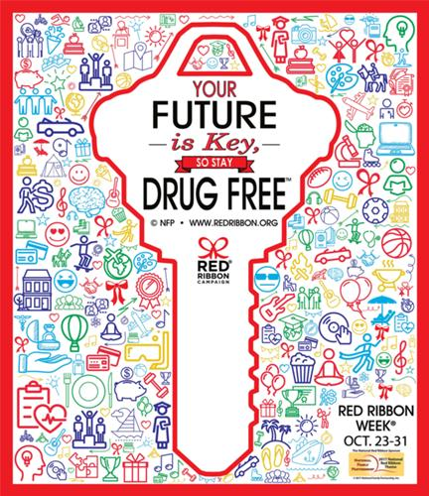
MONDAY, OCTOBER 23
Unlock Red Ribbon Week!
Wear as much RED as possible!

TUESDAY, OCTOBER 24
My Future is Too Bright for Drugs!
Wear NEON or BRIGHT COLORS!
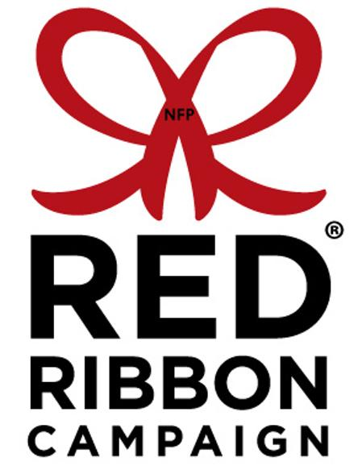
WEDNESDAY, OCTOBER 25
Head to Toe, I’m Drug-Free!
Wear CRAZY SOCKS!

THURSDAY, OCTOBER 26
Stay in the Game and Play in a Drug-Free Future!
Wear your FAVORITE TEAM JERSEY or SHIRT!
FRIDAY, OCTOBER 27
Hats Off to Staying Drug-Free!
Wear a HAT to school!

